# Exercises: HTML5 and CSS

Problems for exercises and homework for the [“Software Technologies” course @ SoftUni](https://softuni.bg/courses/software-technologies).

Now that we have our home page, fully designed, we can start designing the other web pages, necessary for our web application. Because the web pages follow a similar design it will be relatively easy to structure their architecture and styles.

# Designing the Login page

## Create Login page

Create an html file called “login.html”. Set the page title to “Login”. Import “style.css” in it, and then create another stylesheet file called “form-style.css” and import it into the current page too. This stylesheet will hold our form’s style. You will see what the form is later.

Initialize the head structure of the page in the same way it was done for the home page.

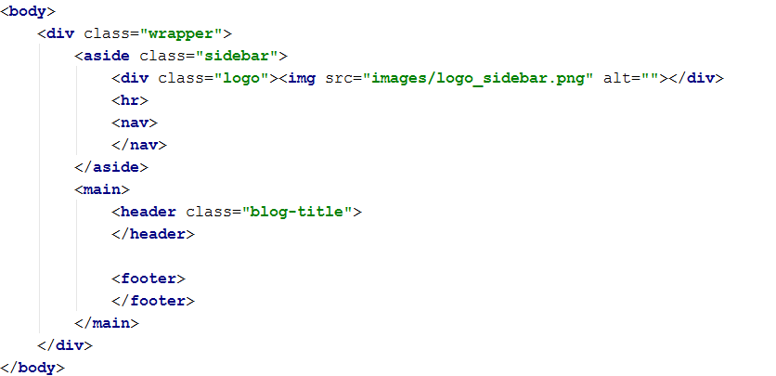

## Copying the sidebar architecture

Due to our web application’s consistency aim, the sidebar of the page is exactly the same as the home page’s sidebar. The only thing that changes in the login page is the main content.

Copy the sidebar section content from the home page. If everything is done correct, it should look like this:



## Designing the main content structure

The current page is a login page. That is why it will hold a login **form**. Let’s initialize the structure of the main content.

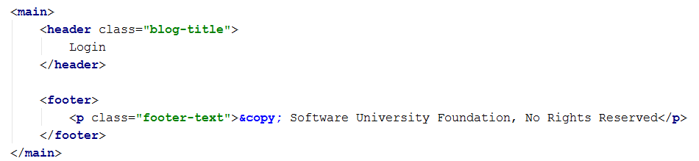

As we see, the header of the main content of the login page is different from the home one. The footer however is the same, for all pages.

## Creating the form holder

Let’s create a simple div block to hold our login form, and put our form in it.

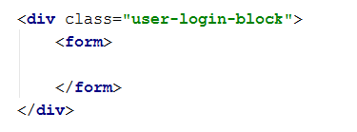

The **<form>** tag is used to create a HTML form for user input.

## Designing the input of the form

Now that we have a form, let’s create 2 input fields, one for username and one for password – same as every other login form.

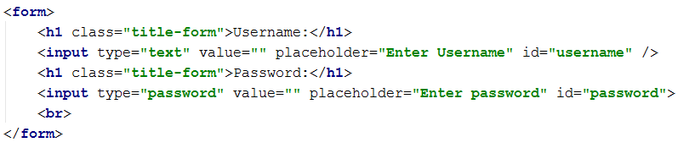

The **<input>** tag is used to create an HTML input field for the users. As we see, aside from the input fields, we also have headings, which function as captions for our input fields, which will make the layout and design of the form a bit more creative. Set the attributes exactly as specified above.

The input tag has a type – it can be plain text, or password. If its password it will not visualize the content written in it.

The placeholder attribute specifies what will be the default content in the input before any input is entered. This is done to make the form inputs more user-friendly.

After the input fields we have a **<br>** tag, which is a simple tag used to create a single line-break.

## Creating the Login form button

Every form has a button, which is used to submit the data from the form and send it to an appropriate handler which will process it. In HTML buttons are create with the **<button>** tag.

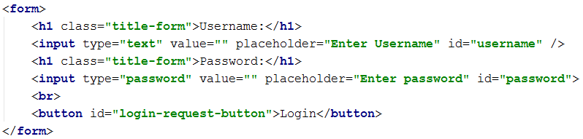

## Designing the register, redirection button

In case a user does not have a registration, we should provide him with a link to our registration page, which we will implement later.

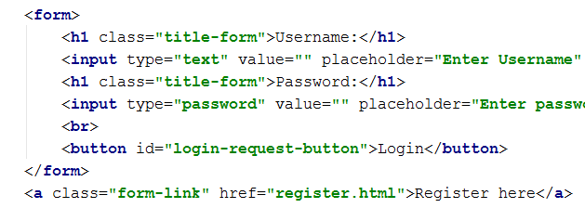

## Styling the login page

We have reached the styling phase again. We will start with the highest element in the architecture hierarchy, which is the wrapper. This page will be a bit more interesting – it will have a background.

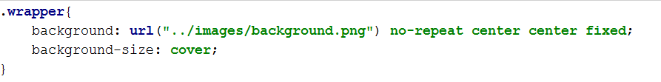

The background property is used to specify the background styles for a particular element. The background can be a picture too. The no-repeat property specifies that the background image will not repeat if the back screen is too big, because some browsers tend to do that in order to cover the whole screen. Then we have positioning properties, vertical and horizontal, which are both centered. And last but not least, we set the position to fixed.

The background-size property is used to manually set a size to the background of an element. In our case its value is **cover**, which means that the browser will stretch the picture in order to cover the whole background.

## Styling the form holder

Next we will style our form holder.

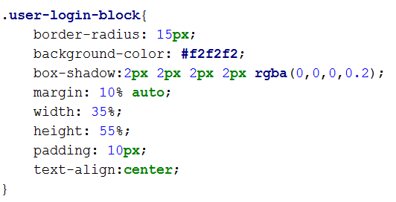

Follow the pictures exactly, otherwise the layout might not be the same as we expect it to be.

## Styling the form and the form title

Let’s put some styling to the form too:

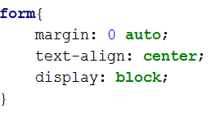

And the form’s title:

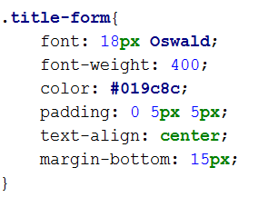

## Styling the input fields

We have reached the moment to design our input fields and make them a bit more beautiful:

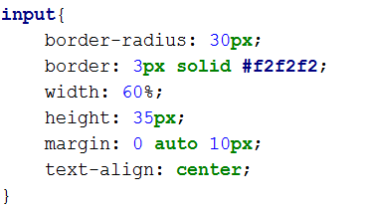

We use the border-radius property to make it a bit more rounded, which will give some design to our input fields.

Next, comes the **focus** event of the input fields.

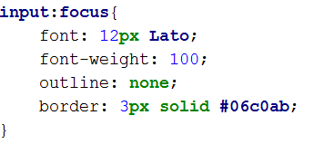

Similar to the **hover** effect, the focus effect selector applies its styles on the current element when it is focused.

## Styling the form buttons

The buttons of the form should also hold some custom style in order to follow the style pattern of the page.

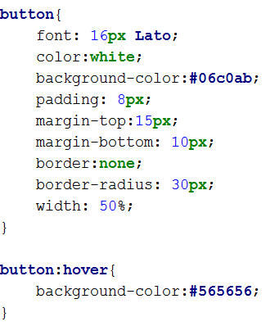

The hover effect of the button is a bit more interesting, it changes the background of the element on hover effect.

## Styling the register, redirection link

Despite being a simple link, it still requires styling:

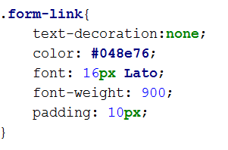

## Styling the footer

The footer’s style is the same for all the pages, but still:

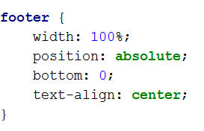

## Revision

If you’ve completed everything you should see the following layout of the login page.

